**HOME WIRELESS NETWORK DESIGN**

A COURSE PROJECT REPORT

By

**Swarnim Dubey (RA1911003010321)**

**Palak Saxena (RA1911003010339)**

**Devash Bishnoi (RA2011003011280)**

**Maitreyee Joshi (RA2011003011299)**

Under the guidance of   
**Mr.S.Saminathan***In partial fulfilment for the Course*

18CSC302J - COMPUTER NETWORKS

in the Department the of Computing Technologies



**FACULTY OF ENGINEERING AND TECHNOLOGY**

**SRM INSTITUTE OF SCIENCE AND TECHNOLOGY**

**Kattankulathur, Chenpalpattu District**

NOVEMBER, 2022

**SRM INSTITUTE OF SCIENCE AND TECHNOLOGY**

**(Under Section 3 of UGC Act, 1956)**

**BONAFIDE CERTIFICATE**

Certified that this mini project report "**Home Wireless Network Design**" is the bonafide work of **Swarnim Dubey (RA2011003011286), Palak Saxena (RA2011003011287) , Devash Bishnoi (RA2011003011280) and Maitreyee Joshi (RA2011003011299)** who carried out the project work under my supervision.

# SIGNATURE

**S.Saminathan**

# Assistant Professor

Department of C.Tech.

SRM Institute of Science and Technology

# ACKNOWLEDGEMENT

We express our heartfelt thanks to our honorable **Vice Chancellor, Dr.C.Muthamizhchelvan**, for being the beacon in all our endeavors.

We would like to express our warmth of gratitude to our **Registrar, Dr. S. Ponnusamy,** for his encouragement

We express our profound gratitude to our **Dean (College of Engineering and Technology), Dr.T.V.Gopal,** for bringing out novelty in all executions.

We would like to express our heartfelt thanks to **Chairperson, School of Computing**, **Dr.Revathi Venkataraman,** for imparting confidence to complete our course project.

We extend our gratitude to our **HoD,** **Dr.M.Pushpalatha, Professor and Head, Department of Computing Technologies** and our Departmental faculty members for their Support.

We wish to express our sincere thanks to **Course Audit Professor, Dr.Annapurani Panaiyappan, Professor and Head, Department of Networking and Communications** and the **Course Coordinators** for their constant encouragement and support.

We are highly thankful to our Course project Faculty mentor, **Mr.S.Saminathan, Assistant Professor, Department of C.Tech.,** for his assistance, timely suggestion and guidance throughout the duration of this course project.

Finally, we thank our parents and friends near and dear ones who directly and indirectly contributed to the successful completion of our project. Above all, we thank the almighty for showering his blessings on us to complete our Course project.

**TABLE OF CONTENTS**

|  |  |  |
| --- | --- | --- |
| **SL. NO.** | **CHAPTER HEADING** | PAGE NO. |
| **1.** | **ABSTRACT** | **5** |
| **2.** | **INTRODUCTION** | **6** |
| **3.** | **LITERATURE SURVEY** | **7** |
| **4.** | **REQUIREMENT ANALYSIS** | **8** |
| **5.** | **ARCHITECTURE & DESIGN** | **10** |
| **6.** | **IMPLEMENTATION** | **11** |
| **7.** | **EXPERIMENT RESULTS & ANALYSIS** | **12** |
|  | **7.1 RESULTS** | **12** |
|  | **7.2 RESULT ANALYSIS** | **13** |
| **8.** | **CONCLUSIONS & FUTURE ENHANCEMENT** | **14** |
| **9.** | **REFERENCES** | **15** |

# ABSTRACT

A wireless network has to be designed at home with remote access from the office. There are 3 users at home. Two users have a desktop and the third user has a laptop. A high-speed cable internet connection is available at home. A serial port printer is available for printing.

A network for the same was designed using Cisco Packet Tracer version 8.0.0. The requirements were emulated and tested for connectivity. A server was setup, which is accessible only on port 443 with HTTPS connectivity. Internally, department routers are interconnected for unfiltered access to the server.

The company router has NAT to translate public IP address to private device IP addresses. Switches are used to ensure optimal number of devices can be used with both the company network as well as the broadband network.

Pings were used to check the connectivity and the reachability of the systems from all the network.

1. **INTRODUCTION**
   1. **Scenario Description**

The planet is becoming increasingly more mobile over the past few years. The worlds conventional ways of networking have proved insufficient to address the challenges raised by our current collective lifestyle. When users need to be connected by physical cables to a network, their movement is drastically reduced.

A wireless network allows devices to remain linked to the network yet to roam without any cables unattached. Wi-Fi signals are amplified by access points, meaning a computer can be far from a router but still be linked to the network. You connect to that organization’s wireless network when you connect to a Wi-Fi hotspot at a cafe or another public location.

The only difference between wireless and wired network is that wired network uses cables to link devices to the Internet or another network, such as laptops or desktop computers. As opposed to a wireless network, a wired network has several drawbacks. The main downside is that a router is tied to your computer. The most popular wired networks use cables attached to an Ethernet port on the network router and the other end to a computer or other system.

1. **LITERATURE SURVEY**

A wireless network, often called Wi-Fi, connects devices to each other and to the Internet without using cables. A home network is a group of devices – such as computers, game systems, printers, and mobile devices – that connect to the Internet and each other. Home networks connect in two ways:

* A wired network, which connects devices like printers and scanners with cables
* A wireless network, which connects devices like tablets and e-readers without cables

There are many reasons to establish a home network. Here are just a few of the things home networking. It Connect to the Internet from multiple computers, game systems, mobile devices, and more. It Access files and folders on all devices connected to the network. It Prints from multiple computers on a single printer. Also Manage security settings for all networked devices in one place.

Many people find that a mix of wireless and wired networking meets their needs best. For instance, devices that stream movies benefit from the quicker and more stable wired connection. Devices like laptops or tablets, however, benefit from the mobility available with a wireless connection.

1. **REQUIREMENTS**
   1. **Requirement Analysis**

**Network requirements**

Home Office devices can connect as follows:

1. Laptops and tablets connect wirelessly to a home router.

2. A network printer connects using an Ethernet cable to the switch port on the home router.

3. The home router connects to the service provider's cable modem using an Ethernet cable.

4. The cable modem connects to the Internet service provider (ISP) network.

**Hardware Requirement**

Hardware points to consider include:

● May require switch standards applicable for VLAN which support PoE, VLAN or capacity.

● Older hardware is incompatible with new security standards;

● Can older hardware support the new wireless cards?

● Is there room for them?

1. Wireless Network Adapters

Wireless network adapters (also known as wireless NICs or wireless network cards) are

required for each device on a wireless network.

2. Wireless Routers and Access Points

Wireless routers are the heart of a wireless network. These routers function comparable to

routers for wired Ethernet networks.

3. Wireless Antennas

Access points and routers can use a Wi-Fi wireless antenna to increase the communication

range of the wireless radio signal.

4. Wireless Repeaters

A wireless repeater connects to a router or access point to extend the reach of the network

1. **ARCHITECTURE AND DESIGN**
   1. **Network Architecture**

The network architecture is as follows:

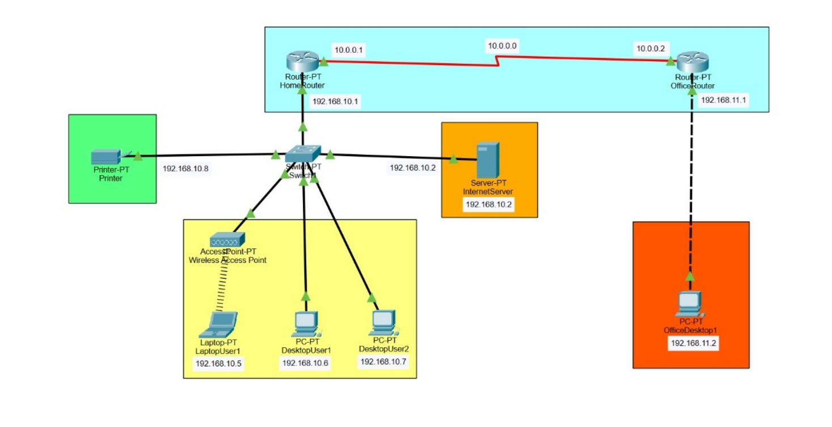

The architecture consists of three major networks:

* Personal Computers
* Devices like printers
* Network maintained by the Internet Service Provider

These networks are interconnected with each other with varying degrees (discussed in the implementation chapter).

1. **IMPLEMENTATION**

Identifying which services and applications the WLAN must support is a key to building a robust, relevant, scalable and sustainable architecture.

It is strongly urged to consider the following elements of any one-to-one initiative:

- Number of NOUN SST staff using the WLAN.

- Types of application(s) being utilized

- Throughput requirements

- Special attention should be considered for NOUN SST staff taking their laptops home to access the Internet or other resources.

● Obtain floor plans for the office and home to assist in setup.

● Determine how many Access Points. It will take to provide a signal to the desired coverage area.

● Physical Access Points placement map- Identify signal trouble areas and physical construction or environmental challenges. Determine user policies for the wireless network.

● Diagram channel layout of Access Points.

● Confirm hardware compatibility (include desired legacy hardware, new hardware and current or future for staff-owned device standards)

Verify that each Access Points location is physically secure.

● Verify that there is a power source near the intended location for each Access Point or Power over Ethernet Compatibility.

● Confirm there is a way to run a patch cable between your wired network and each AP and/or APs to be used as repeaters. List specialized antennae requirements.

● Determine AP network cabling distances and are within CAT-5 or 6 limits (~100m

1. **RESULTS AND DISCUSSION**

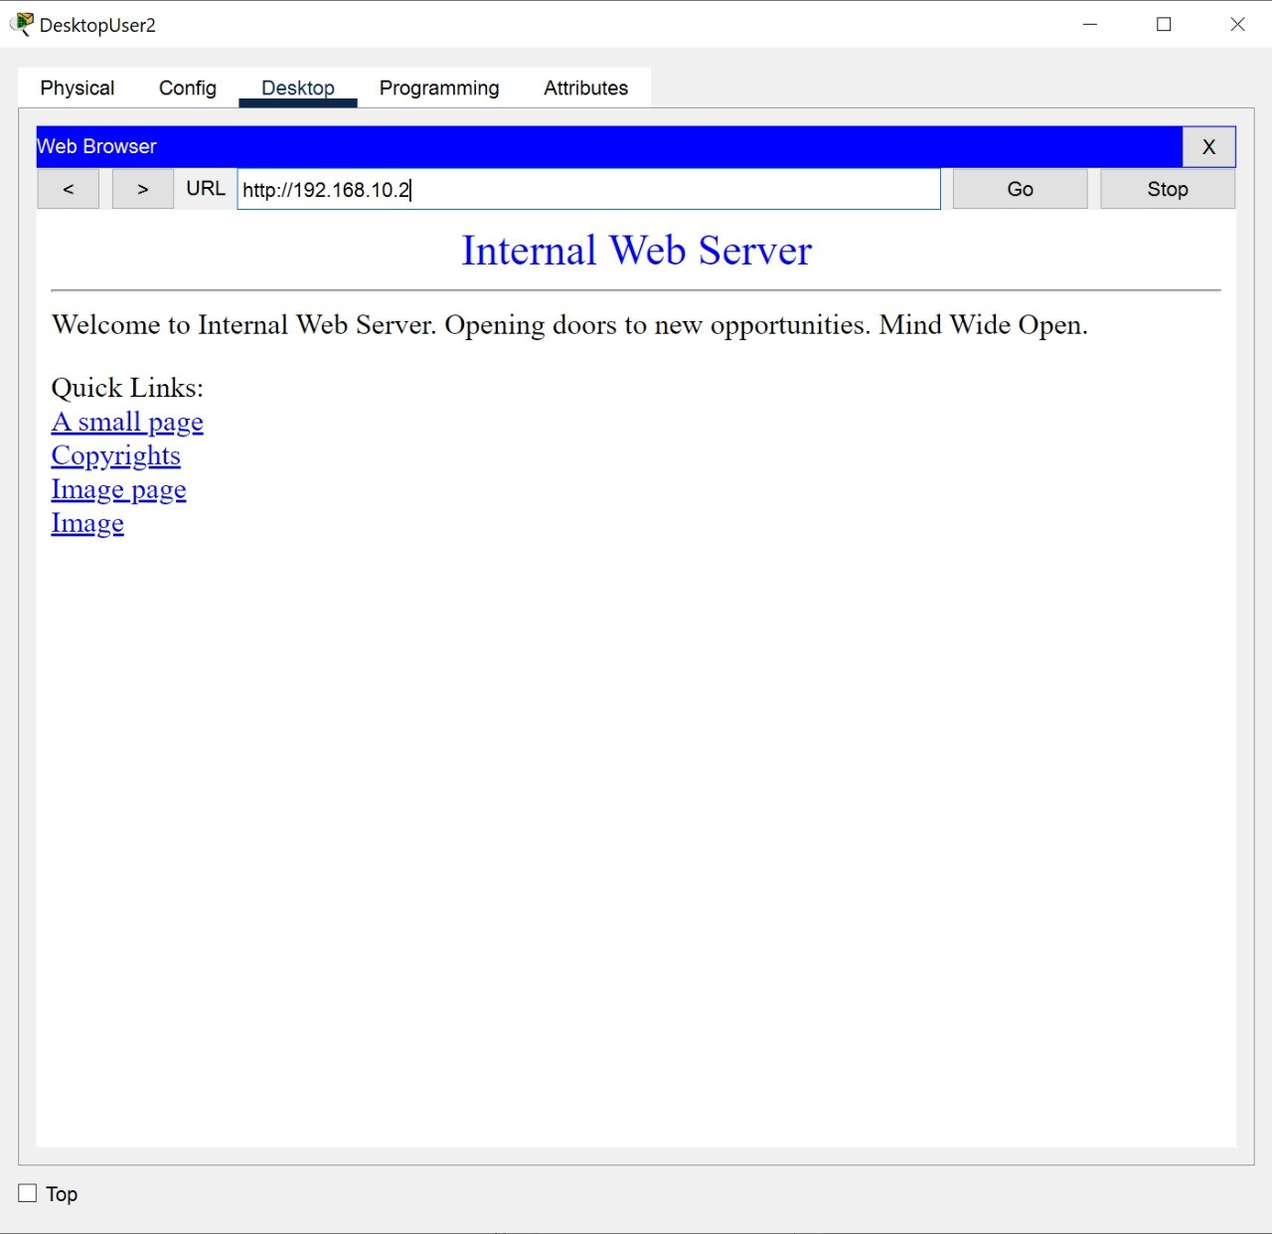

Remote Access to the Internet

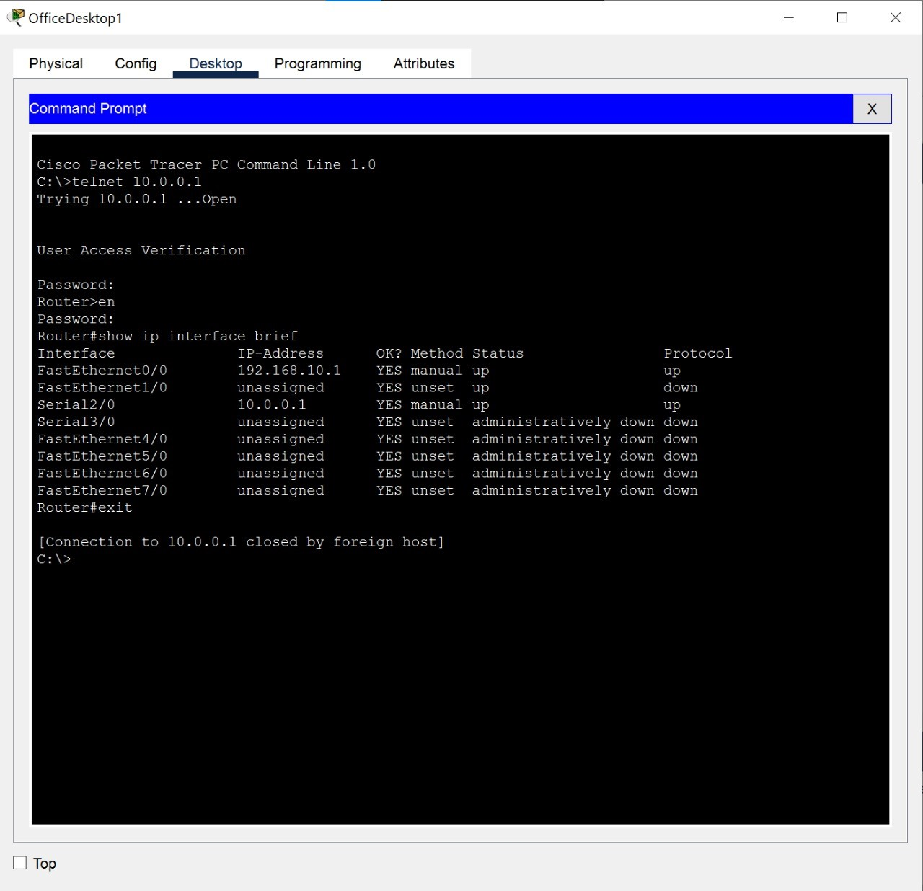

Remote Access to Router

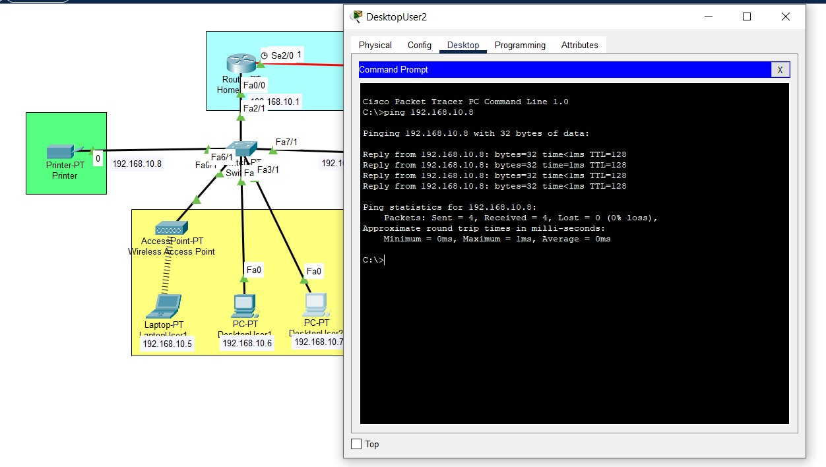

Access to Printer

**Recommended Products:**

* Wireless Access Point:

NETGEAR Wireless Access Point

Ubiquiti Networks Wireless Access Point

Zyxel True WiFi6 Wireless Access Point JOOWIN AC1200 High Wireless Access Point

* Network Switches:

TP-Link TL-SG108 (Unmanaged)

TP-Link TL-SG105-M2

1. **CONCLUSION AND FUTURE ENHANCEMENT**

The concept of home networking is understood and how it must be applied, home network is also set up in cisco packet tracer accordingly.

Basically, a home network or home area network is a type of computer network that facilitates communication among devices within the close vicinity of a home. Connects to the Internet from multiple computers, game systems, mobile devices, and more. Access files and folders on all devices connected to the network. Print from multiple computers on a single printer. Manage security settings for all networked devices in one place. In today’s world home networking is necessary for day to day work.

1. **REFERENCES**

* Anderson, B., C. Gale, A. P. Gower, E. F. France, M. L. R. Jones, H. V. Lacohee, A. McWilliam,
* K. Tracey, and M. Trimby. (2002): Digital Living—People-Centred Innovation and Strategy,
* BT Technology Journal, vol. 20, no. 2, pp. 1-20.
* Brown, B., A. J. Sellen, and E. Geelhoed (2001): Music Sharing as a Computer Supported
* Collaborative Application. In Proceedings of the 7th European Conference on ComputerSupported Cooperative Work ECSCW '01, Bonn, Germany, Sept 16-20. Kluwer, pp. 179-198.
* Chalmers, M. (2004): A Historical View of Context, Computer Supported Cooperative Work
* (CSCW), vol. 13, no. 3, pp. 223-247.
* Crabtree, A. and T. Rodden. (2004): Domestic Routines and Design for the Home, Computer
* Supported Cooperative Work (CSCW), vol. 13, pp. 191-200.
* Cummings, J. N. and R. Kraut. (2002): Domesticating Computers and the Internet, The
* Information Society, vol. 18, no. 3, pp. 221-232.